**Kalman Filters**

LIDAR gets distance measurements 10 times a second of about 1 million data points. This large amount of data is required to accurately place objects and your environment.

Gaining Data about where vehicles currently are is important for localization. It gets us information of other objects are so that there is no collision. However we also need to know how fast they are moving. That way we can use this information to predict where cars are going to be, in order to avoid collisions and hazardous situations. It’s important for all objects, whether it’s a car, a bike, or a pedestrian.

**Kalman Filters** are a very popular technique used to estimate the state of a system. Kalman Filters estimate a **continuous state**, and give us a **Uni-Modal distribution**. Finding out what state you are in in **discrete** states is done with **Monte Carlo Localization**.

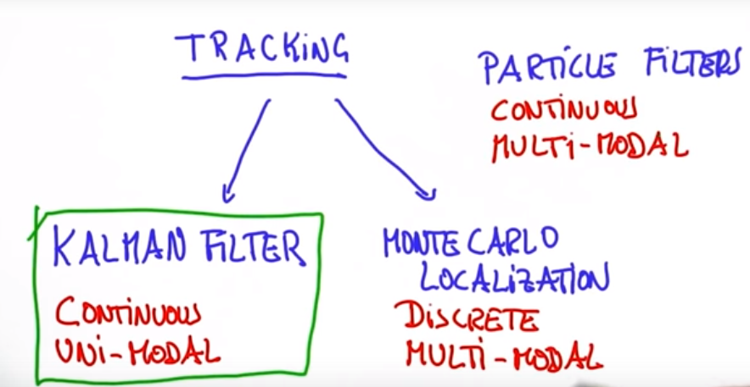

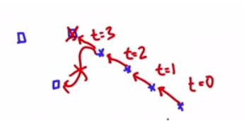If an object is being tracked at the given positions, and we need to estimate the position at t=4, we can assume that given the velocity of the data give, the prediction would follow in the same direction. These are the types of observations a Kalman Filter has. It estimates future positions, and velocities. Kalman filters are useful for these continuous situations.

**Gaussian**